

**Course Title:** CSE110

**Section:** 06

**Semester:** Summer 22

**LAB-03**

**SUBMITTED TO**

Mahamudul Hasan

Department of Computer Science & Engineering

East-West University

***SUBMITTED BY***

**Name:** B M Shahria Alam

**Student ID:** 2021-3-60-016

**Date of submission:** 26 June 2022.

P1)

import java.util.Scanner;

public class P1 {

public static void main(String[] args) {

Scanner in= new Scanner(System.in);

System.out.println("Enter the size of the array: ");

int i,j,a=0;

int n=in.nextInt();

int[]x=new int[n];

System.out.println("Enter the value one by one:");

for(i=0; i<n;i++)

{

x[i]=in.nextInt();

}

for(i=0;i<n;i++)

{

for(j=1; j<n-i;j++)

{

if(x[j-1]>x[j])

{

a=x[j-1];

x[j-1]=x[j];

x[j]=a;

}

}

}

System.out.print("After bubble sort: ");

for(i=0; i<n;i++)

{

System.out.print(x[i]+"\t");

}

}

}

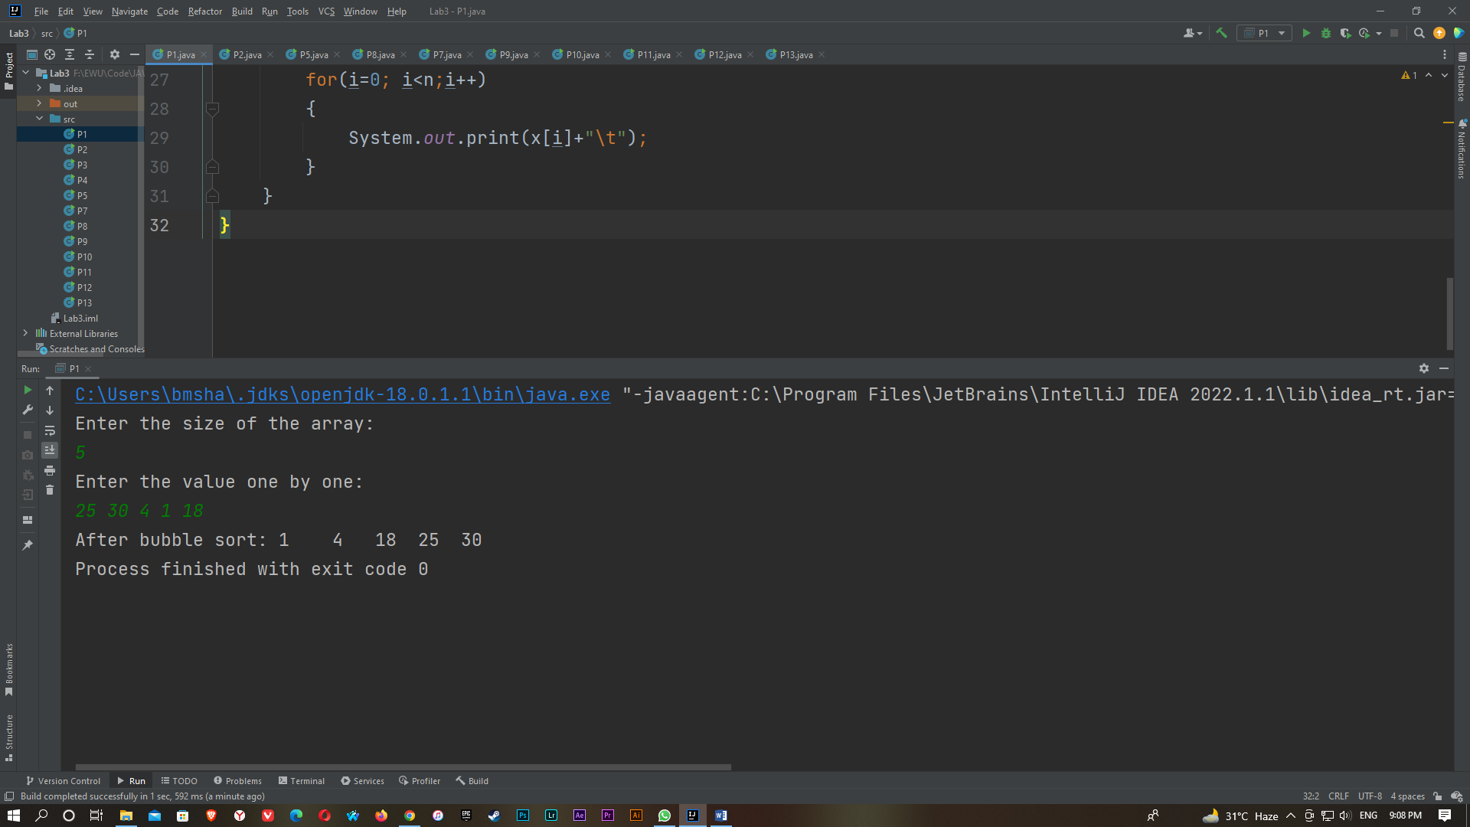

P2)

import java.util.Scanner;

public class P2 {

public static void main(String[] args) {

Scanner in= new Scanner(System.in);

System.out.println("Enter the size of the array:");

int n,a=0,i,j;

n=in.nextInt();

int [] x= new int[n];

System.out.println("Enter the value one by one: ");

for(i=0; i<n; i++)

{

x[i]=in.nextInt();

}

for(i=0; i<n; i++)

{

for(j=1; j<n-1; j++)

{

if(x[j-1]>x[j])

{

a=x[j-1];

x[j-1]=x[j];

x[j]=a;

}

}

}

System.out.println("Second smallest value is: ");

for(i=0; i<n; i++)

{

if(x[i]<x[i+1])

{

System.out.println(x[i+1]);

break;

}

}

}

}

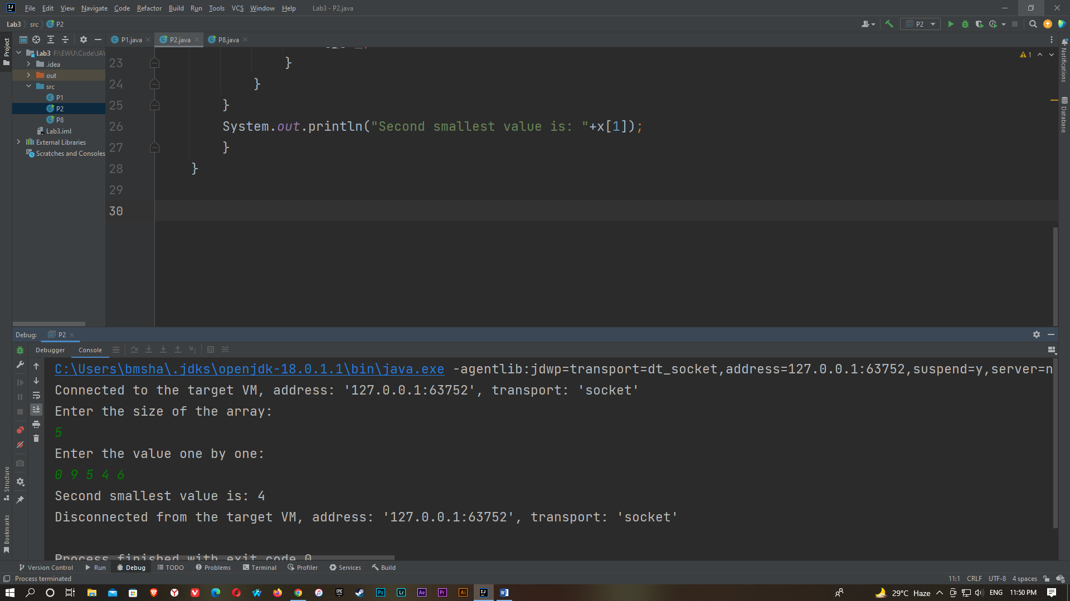

P3)

import java.util.Scanner;

public class P3 {

public static void main(String[] args) {

Scanner in= new Scanner (System.in);

System.out.println("Enter the matrix size: ");

int i,j ,k;

int n= in.nextInt();

int m= in.nextInt();

int [] [] x= new int[n][m];

int [] [] y= new int[n][m];

int [] [] z= new int[n][m];

System.out.println("Enter the elements of 1st matrix:");

for(i=0; i<n; i++)

{

System.out.println("Enter Row "+ (i+1) + " :");

for(j=0; j<m; j++)

{

x[i][j]=in.nextInt();

}

}

System.out.println("Enter the elements of 2nd matrix:");

for(i=0; i<n; i++)

{

System.out.println("Enter Row "+ (i+1) + " :");

for(j=0; j<m;j++)

{

y[i][j]=in.nextInt();

}

}

System.out.println("1st Matrix: ");

for(i=0; i<n; i++)

{

for(j=0; j<m; j++)

{

System.out.print(x[i][j]+" ");

}

System.out.println(" ");

}

System.out.println("2nd Matrix: ");

for(i=0; i<n; i++)

{

for(j=0; j<m; j++)

{

System.out.print(y[i][j]+" ");

}

System.out.println(" ");

}

for (i = 0; i < n; i++)

{

for (j = 0; j < m; j++)

{

for (k = 0; k < n; k++)

{

z[i][j]+=x[i][k] * y[k][j] ;

}

}

}

System.out.println("The multiplication of two matrix is : ");

for(i=0; i<n; i++)

{

for(j=0; j<m; j++)

{

System.out.print(z[i][j]+" ");

}

System.out.println(" ");

}

}

}

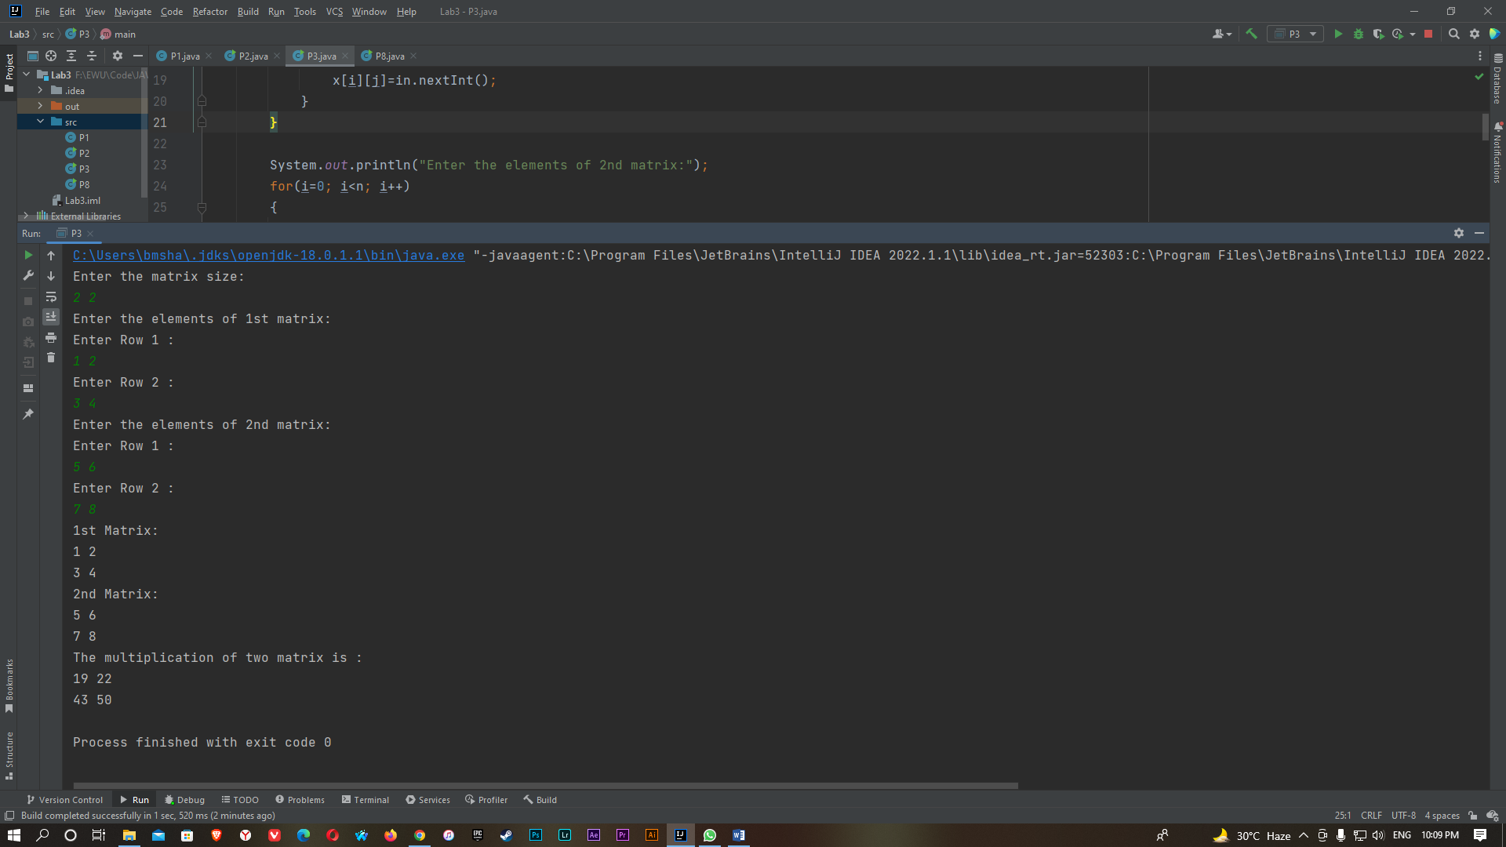

P4)

import java.util.Scanner;

public class P4 {

public static void main(String[] args) {

Scanner in= new Scanner (System.in);

int n,i,j,sum=0;

System.out.println("Input the size of the square matrix :");

n=in.nextInt();

int [][]x =new int[n][n];

System.out.println("Enter the matrix:");

for(i=0; i<n;i++)

{

System.out.println("Enter Row "+ (i+1) + " :");

for(j=0; j<n;j++)

{

x[i][j]=in.nextInt();

}

}

System.out.println("The matrix is :");

for(i=0; i<n;i++)

{

for(j=0; j<n;j++)

{

System.out.print(x[i][j]+ " ");

}

System.out.println(" ");

}

for(i=0; i<n;i++)

{

for(j=0; j<n;j++)

{

if(i==j)

{

sum=sum+x[i][j];

}

}

}

System.out.println("Addition of the right Diagonal elements is :"+sum);

}

}

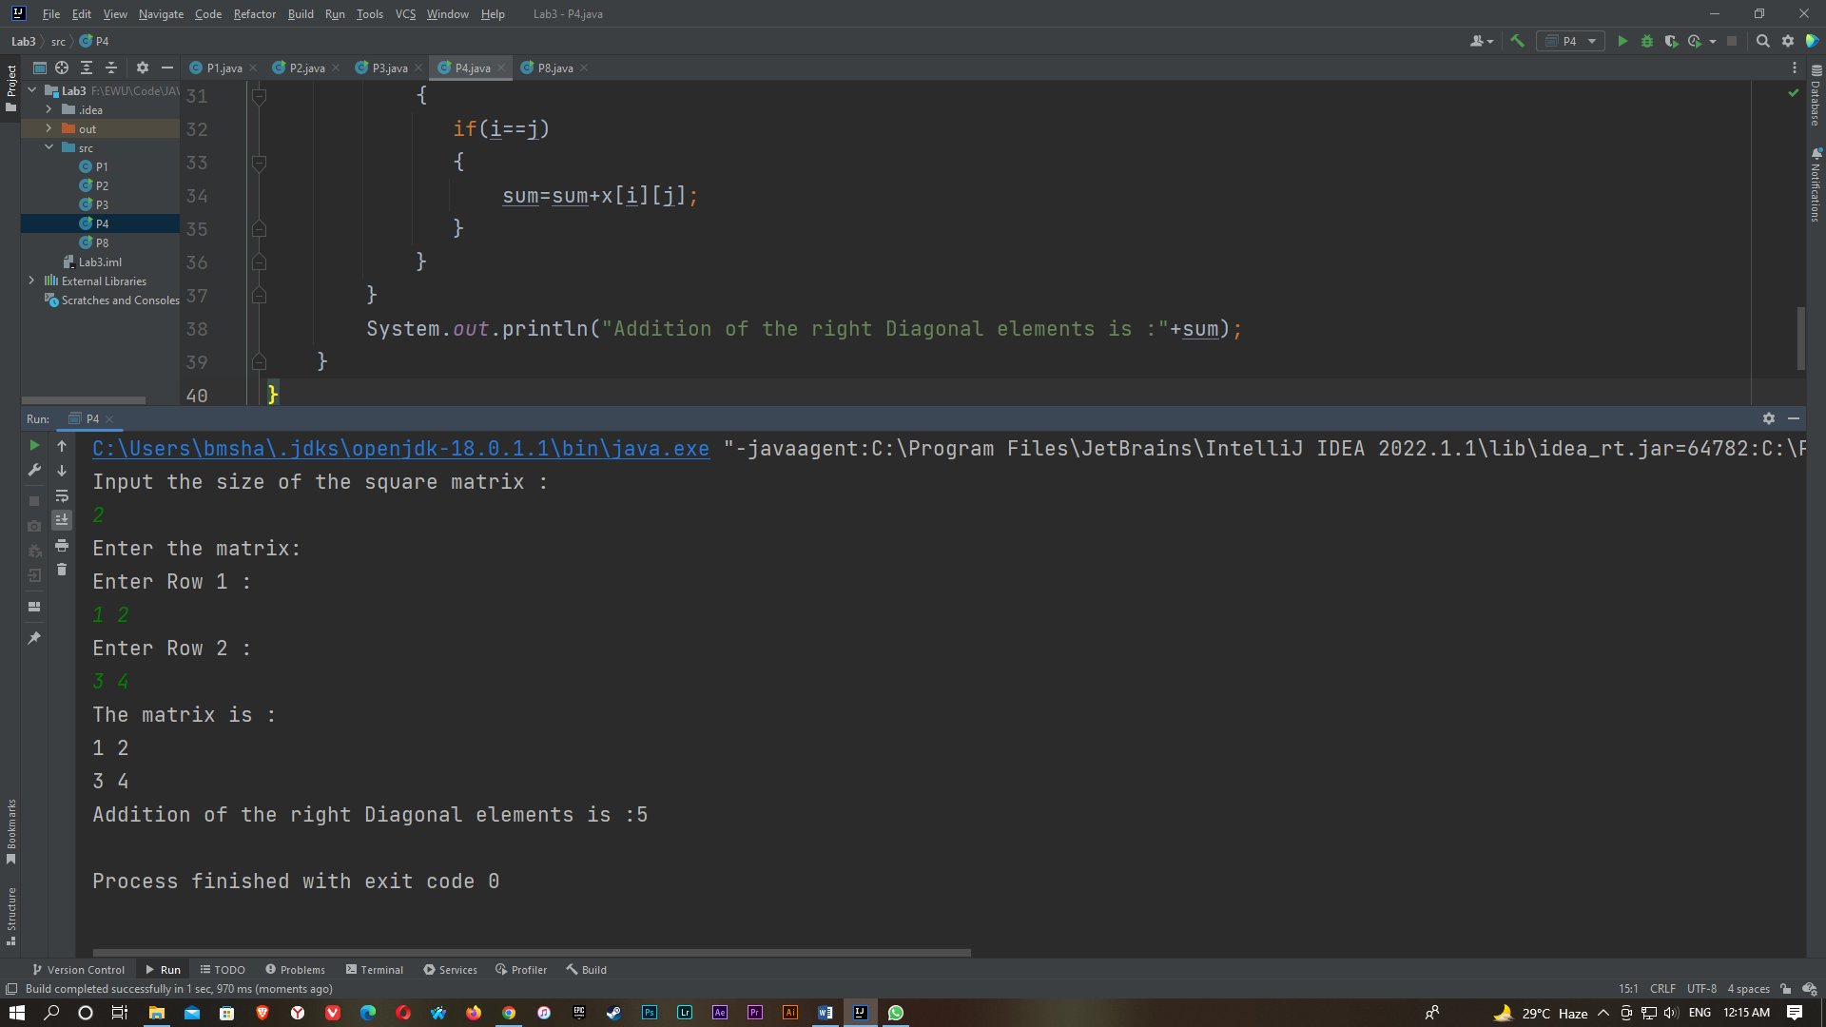

P5)

import java.util.Scanner;

public class P5 {

public static void main(String[] args) {

Scanner in = new Scanner(System.in);

int i,j,a,b,c,d=0;

int[][]x = new int[3][3];

System.out.println("Enter the 3x3 matrix: ");

for (i = 0; i < 3; i++)

{

System.out.println("Enter Row " + (i + 1) + " :");

for (j = 0; j < 3; j++)

{

x[i][j] = in.nextInt();

}

}

System.out.println("The matrix is :");

for (i = 0; i < 3; i++)

{

for (j = 0; j < 3; j++)

{

System.out.print(x[i][j] + " ");

}

System.out.println(" ");

}

a=(x[0][0] * (x[1][1]* x[2][2]-x[1][2]* x[2][1]));

b=(x[0][1] * (x[1][0]* x[2][2]-x[1][2]* x[2][1]));

c=(x[0][2] * (x[1][0]* x[2][1]-x[1][1]* x[2][0]));

d=a-b+c;

System.out.println("The Determinant of the matrix is: "+d);

}

}

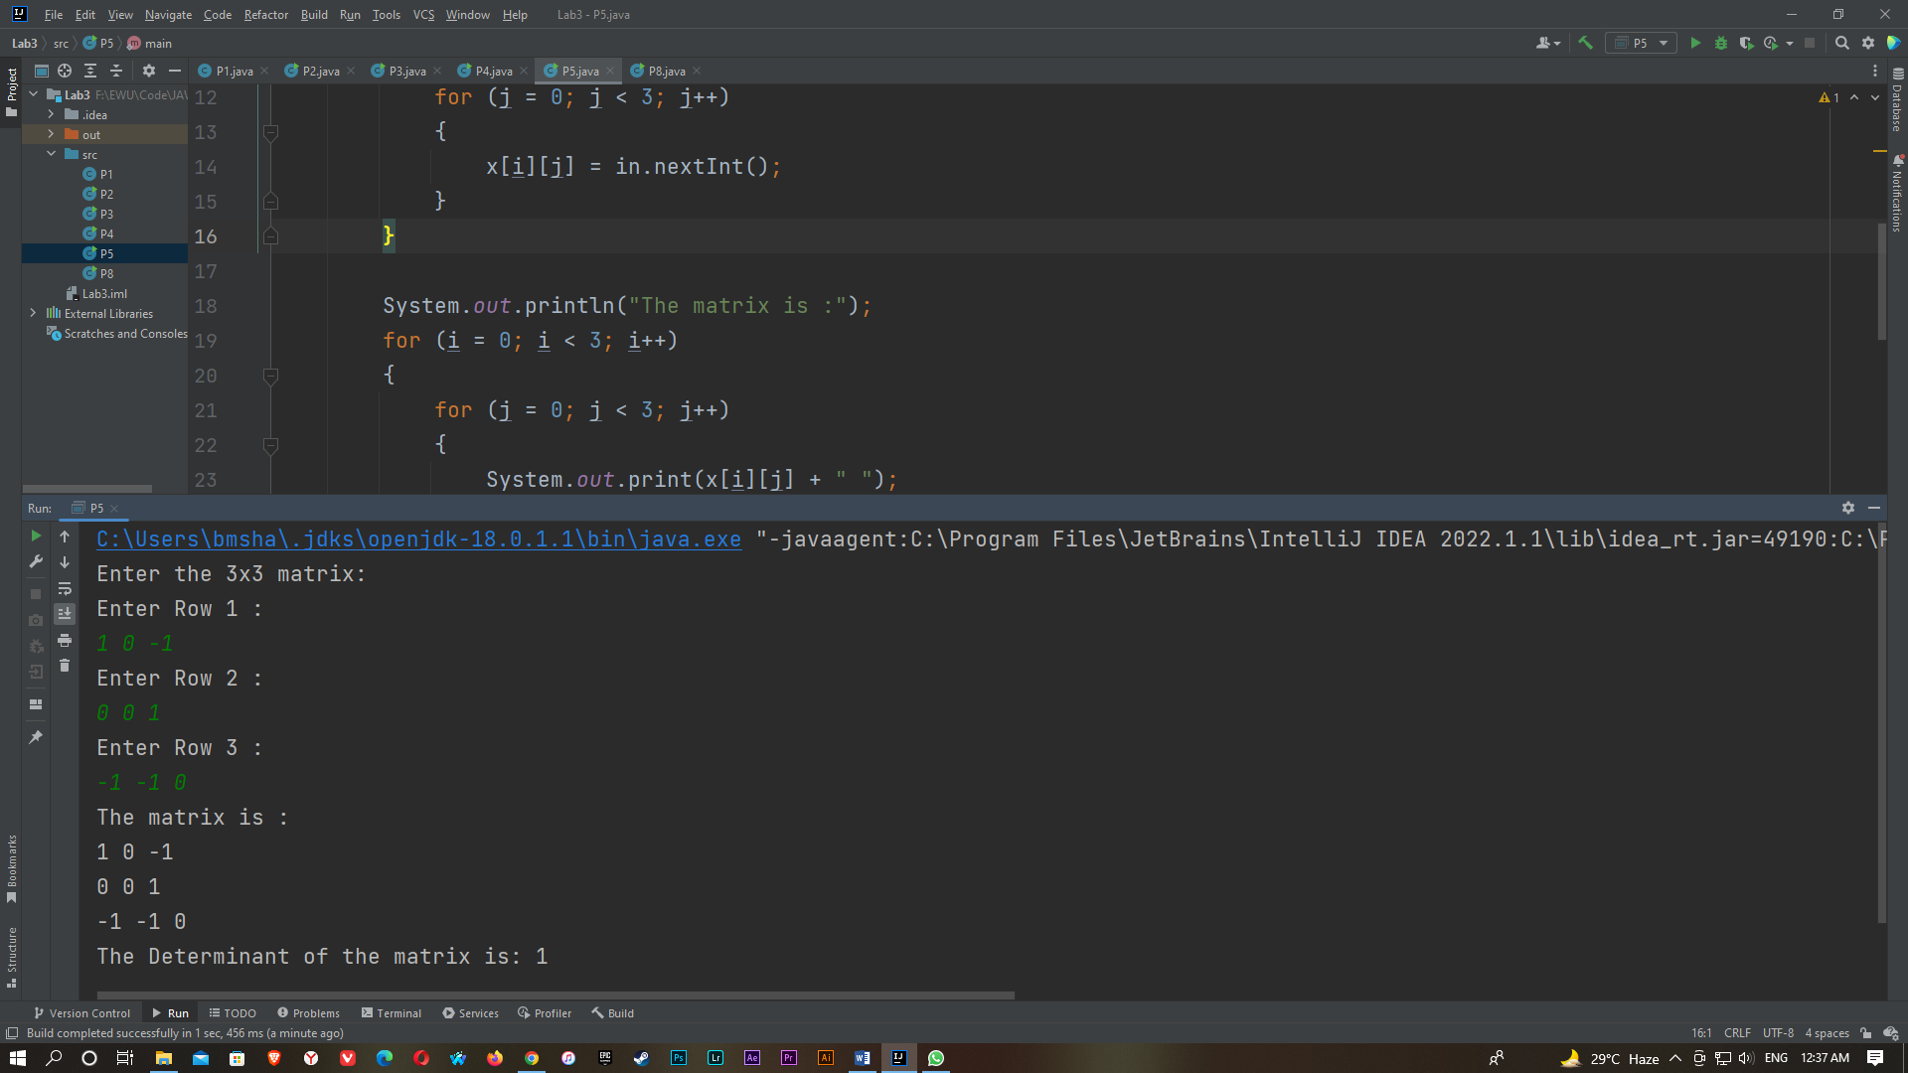

P6)

import java.util.Scanner;

public class P6 {

public static void main(String[] args)

{

Scanner in = new Scanner(System.in);

int x=0,i;

String a,b;

String c[];

System.out.println("Input the string: ");

a = in.nextLine();

System.out.println("Input the substring to search: ");

b = in.nextLine();

c = a.split("\\s+");

for(i=0;i<c.length;i++)

{

if(c[i].equals(b))

{

x++;

}

}

if(x>0)

{

System.out.println("The substring is exist in the string.");

System.out.println("string has been found "+x+" times.");

}

else

{

System.out.println("The substring is not exist in the string.");

System.out.println("no has not been found yet.");

}

}

}

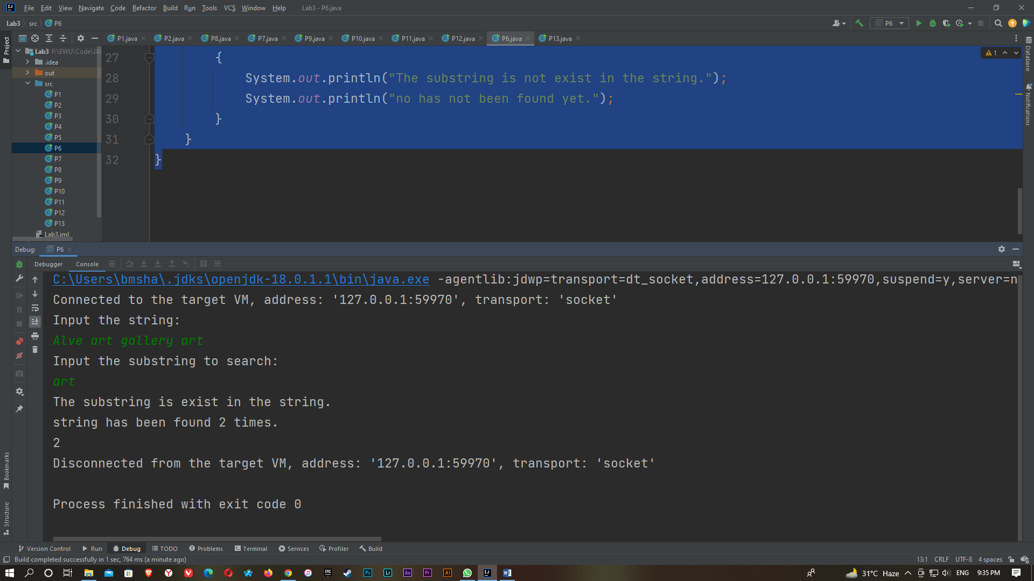

P7)

import java.util.Scanner;

public class P7 {

public static void main(String[] args)

{

Scanner input = new Scanner(System.in);

String a,x,y,c[];

System.out.println("Input the string: ");

a = input.nextLine();

c = a.split("\\s+");

x=c[0];

y = c[0];

int large = c[0].length();

int small=c[0].length();

for(int i=1;i<c.length;i++)

{

if(large<c[i].length())

{

large=c[i].length();

x=c[i];

}

if(small>c[i].length())

{

small=c[i].length();

y=c[i];

}

}

System.out.println("The largest word is '"+x+"'");

System.out.println("and the smallest word is '"+y+"'");

System.out.println("in the string : '"+a+"'");

}

}

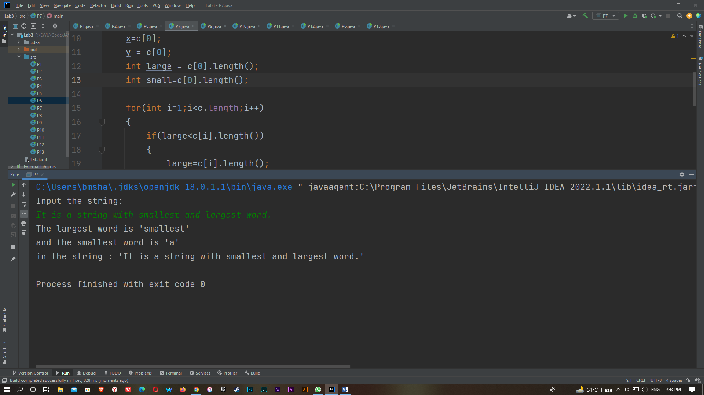

P8)

import java.util.Scanner;

public class P8 {

public static void main(String[] args) {

char a ='\u221A';

char b= '\u2126';

char c= '\u00B1';

char d= '\u2260';

System.out.println("square root ("+a+")");

System.out.println("Ohm ("+b+")");

System.out.println("Plus-Minus ("+c+")");

System.out.println("not equal ("+d+")");

}

}

P9)

import java.util.Scanner;

public class P9 {

public static void main(String[] args) {

Scanner in = new Scanner(System.in);

int x,i;

float y=1,z=0;

System.out.println("Enter the number: ");

x=in.nextInt();

for(i=1;i<=x;i++)

{

y=y*i;

z=z+(y/(float)i);

}

System.out.printf("The sum of this series is :"+z);

}

}

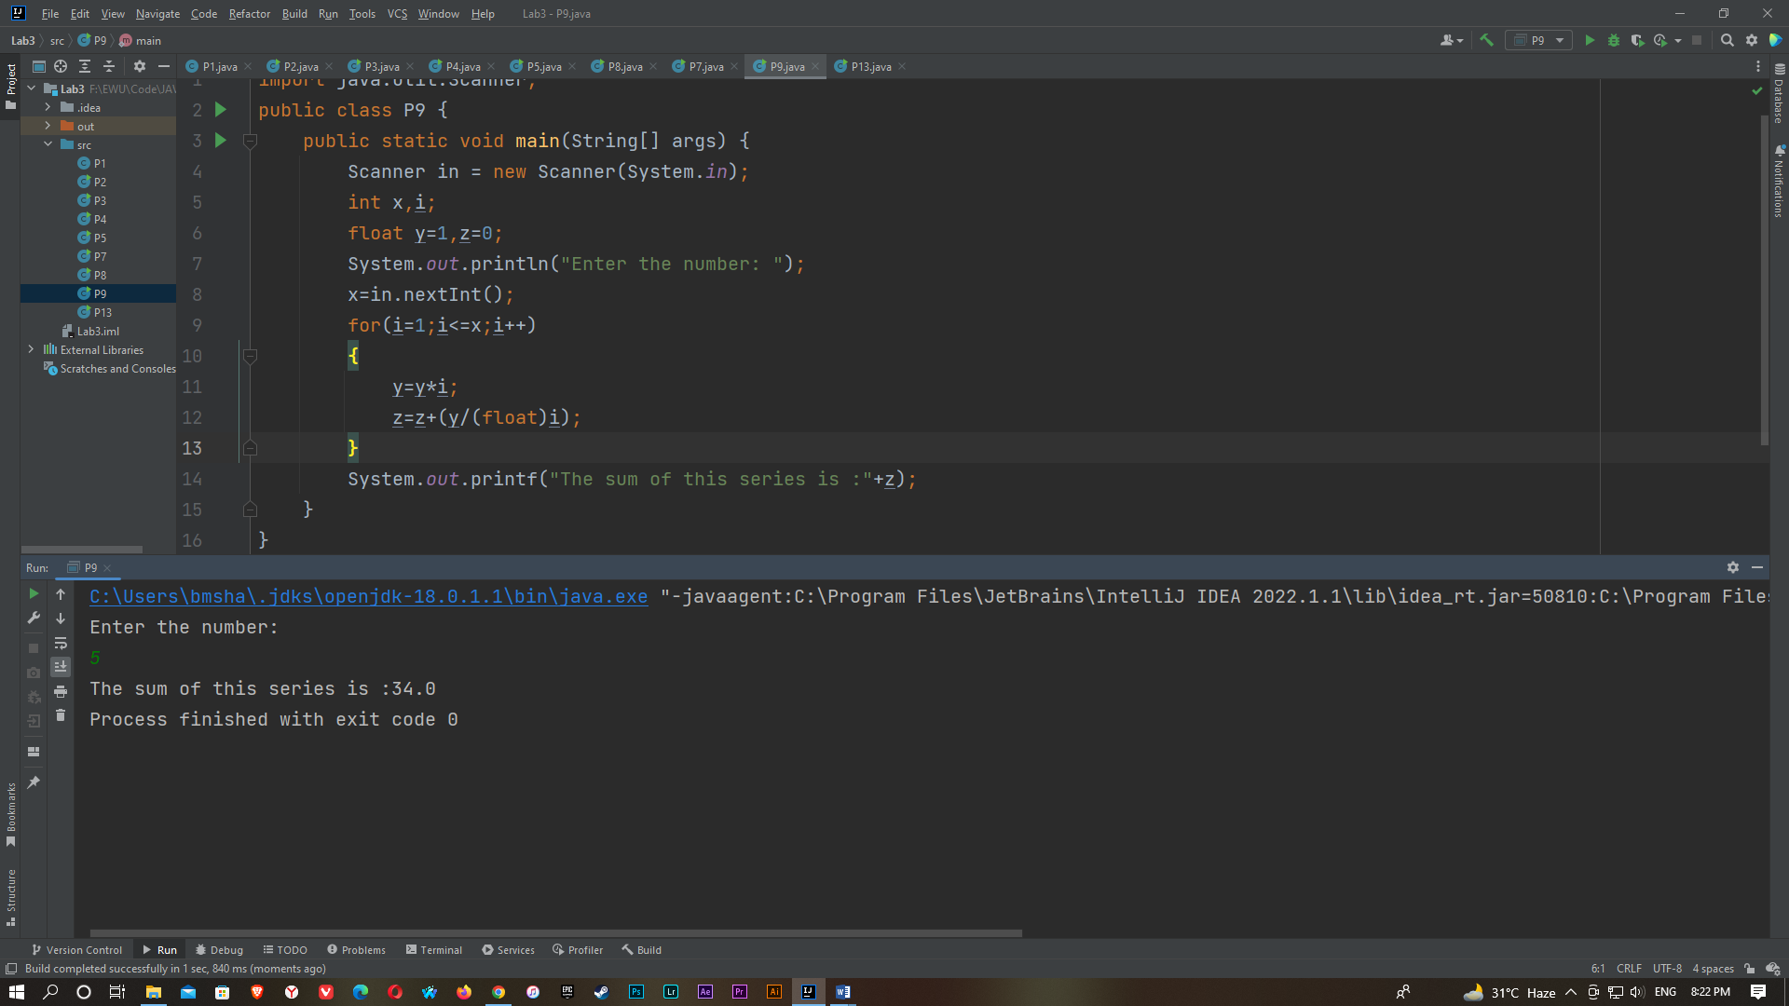

P10)

import java.util.Scanner;

public class P10 {

public static boolean Armstrong(int a)

{

int x,sum=0,num=a;

while(num!=0)

{

x=num%10;

sum=sum+(x*x*x);

num=num/10;

}

return (a == sum);

}

public static boolean Perfect(int a)

{

int i, sum=0, num=a;

for(i=1; i<num; i++)

{

if(num%i == 0)

{

sum += i;

}

}

return (a == sum);

}

public static void main(String[] args) {

Scanner in = new Scanner(System.in);

int x;

System.out.println("Enter the number: ");

x = in.nextInt();

if (Armstrong(x))

{

System.out.println(x + " is an Armstrong number.");

}

else

{

System.out.println(x + " is not an Armstrong number.");

}

if (Perfect(x))

{

System.out.println(x + " is an Perfect number.");

}

else

{

System.out.println(x + " is not a Perfect number.");

}

}

}

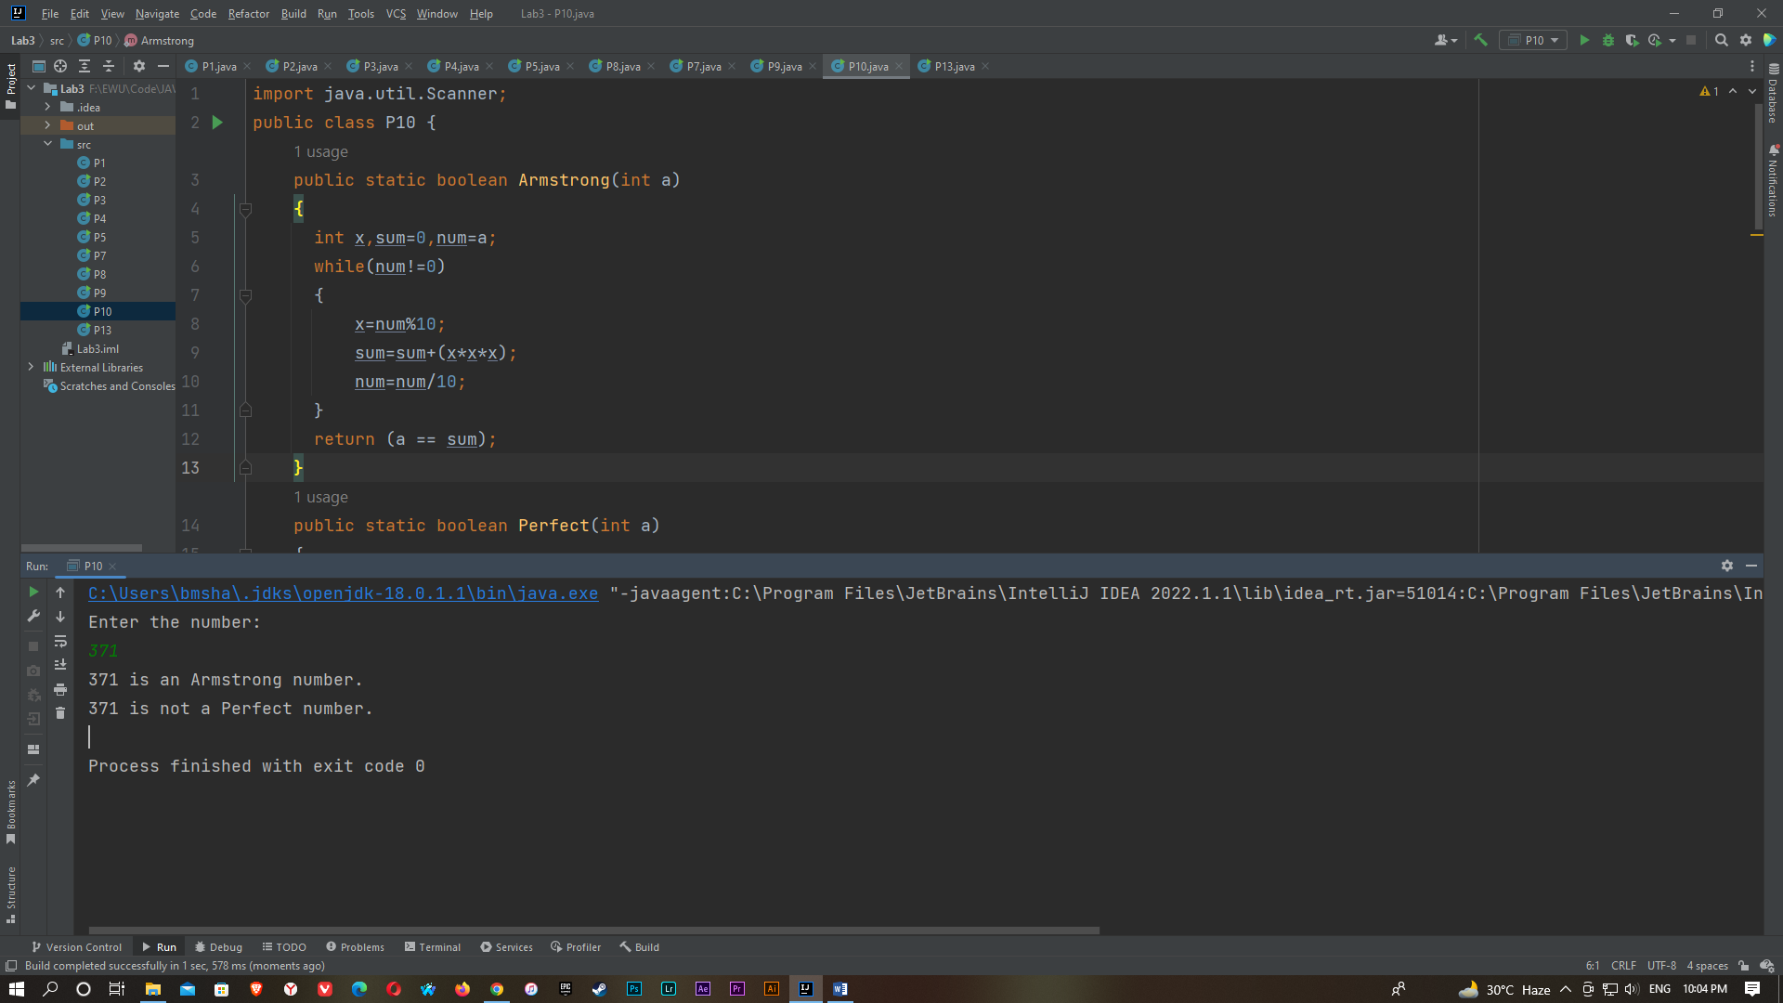

P11)

import java.util.Scanner;

public class P11 {

public static void main(String[] args) {

Scanner input = new Scanner(System.in);

System.out.print("1. A password must have at least eight characters.\n"+

"2. A password consists of only letters and digits.\n"+

"3. A password must contain at least two digits \n"+

"Enter the password:\n");

String s = input.nextLine();

if (s.length()<8)

{

System.out.println("Not a valid password: "+s);

}

if(s.length()>=8)

{

int a = 0, b = 0;

for (int i = 0; i <s.length(); i++) {

char ch = s.charAt(i);

if (ch >= '0' && ch <= '9')

{

a++;

}

else if ((ch >= 'A' && ch <= 'Z') || (ch >= 'a' && ch <= 'z'))

{

b++;

}

}

if (a >= 2 && b >= 2)

{

System.out.println("Password is valid: "+s);

}

else

{

System.out.println("Not a valid password: "+s);

}

}

}

}

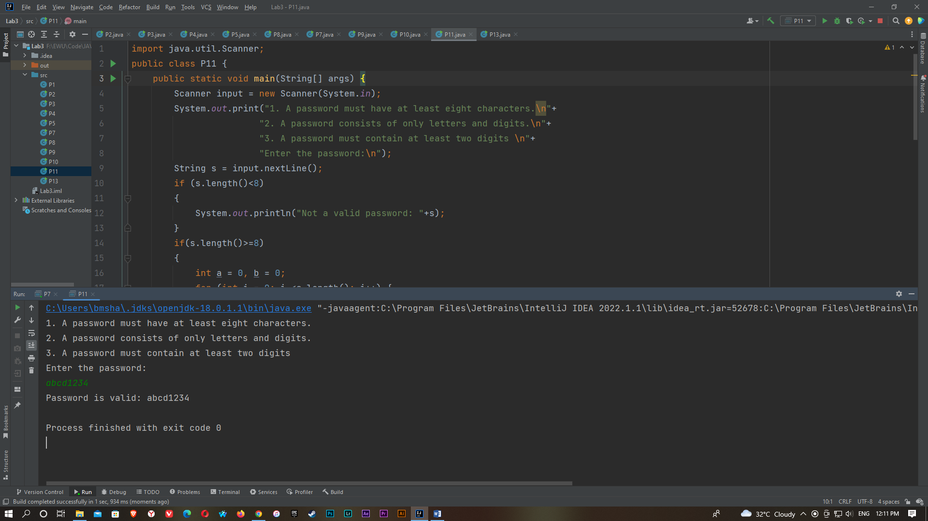

P12)

import java.util.Scanner;

public class P12 {

public static int prime (int n)

{

int i, a=0;

for (i = 2; i <= n / 2; i++)

{

if (n % i == 0)

{

a = 1;

break;

}

}

return a;

}

public static void main(String args[]) {

Scanner in = new Scanner(System.in);

int n, i;

System.out.println("Enter the limit: ");

n = in.nextInt();

System.out.println("Two prime numbers are: ");

for (i = 2; i <= n; i++)

{

if (prime(i) == 0 && prime(i + 2) == 0)

{

System.out.println("(" +i+ "," +(i + 2)+ ")");

}

}

}

}

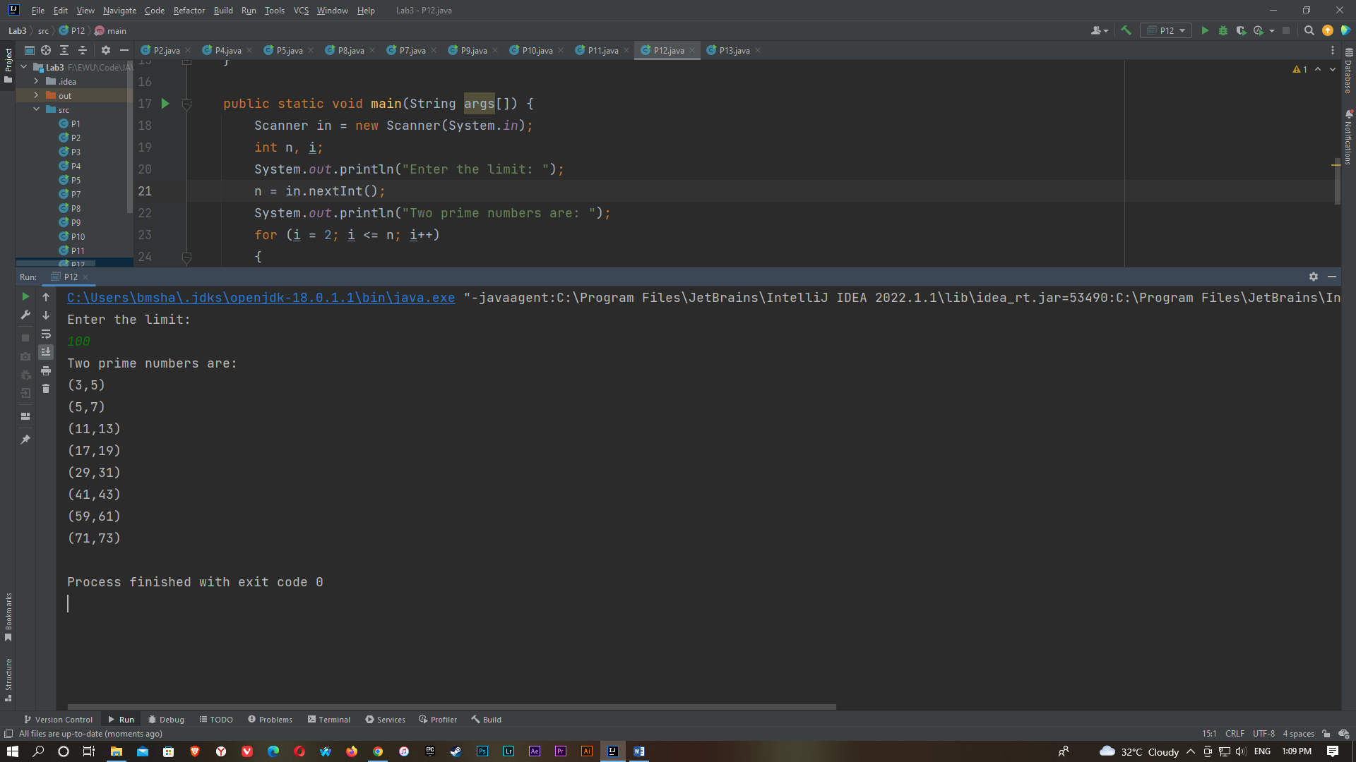

P13)

import java.util.Scanner;

public class P13

{

public static int fact (int x)

{

if (x==0 || x==1)

{

return 1;

}

else

{

return (x* fact (x-1));

}

}

public static void main(String[] args)

{

Scanner in = new Scanner(System.in);

int x, n;

System.out.println("Enter any number:");

x = in.nextInt();

if(x<0)

{

System.out.print("Invalid number");

}

else

{

n=fact(x);

System.out.println("The factorial of "+x+" : "+n);

}

}

}

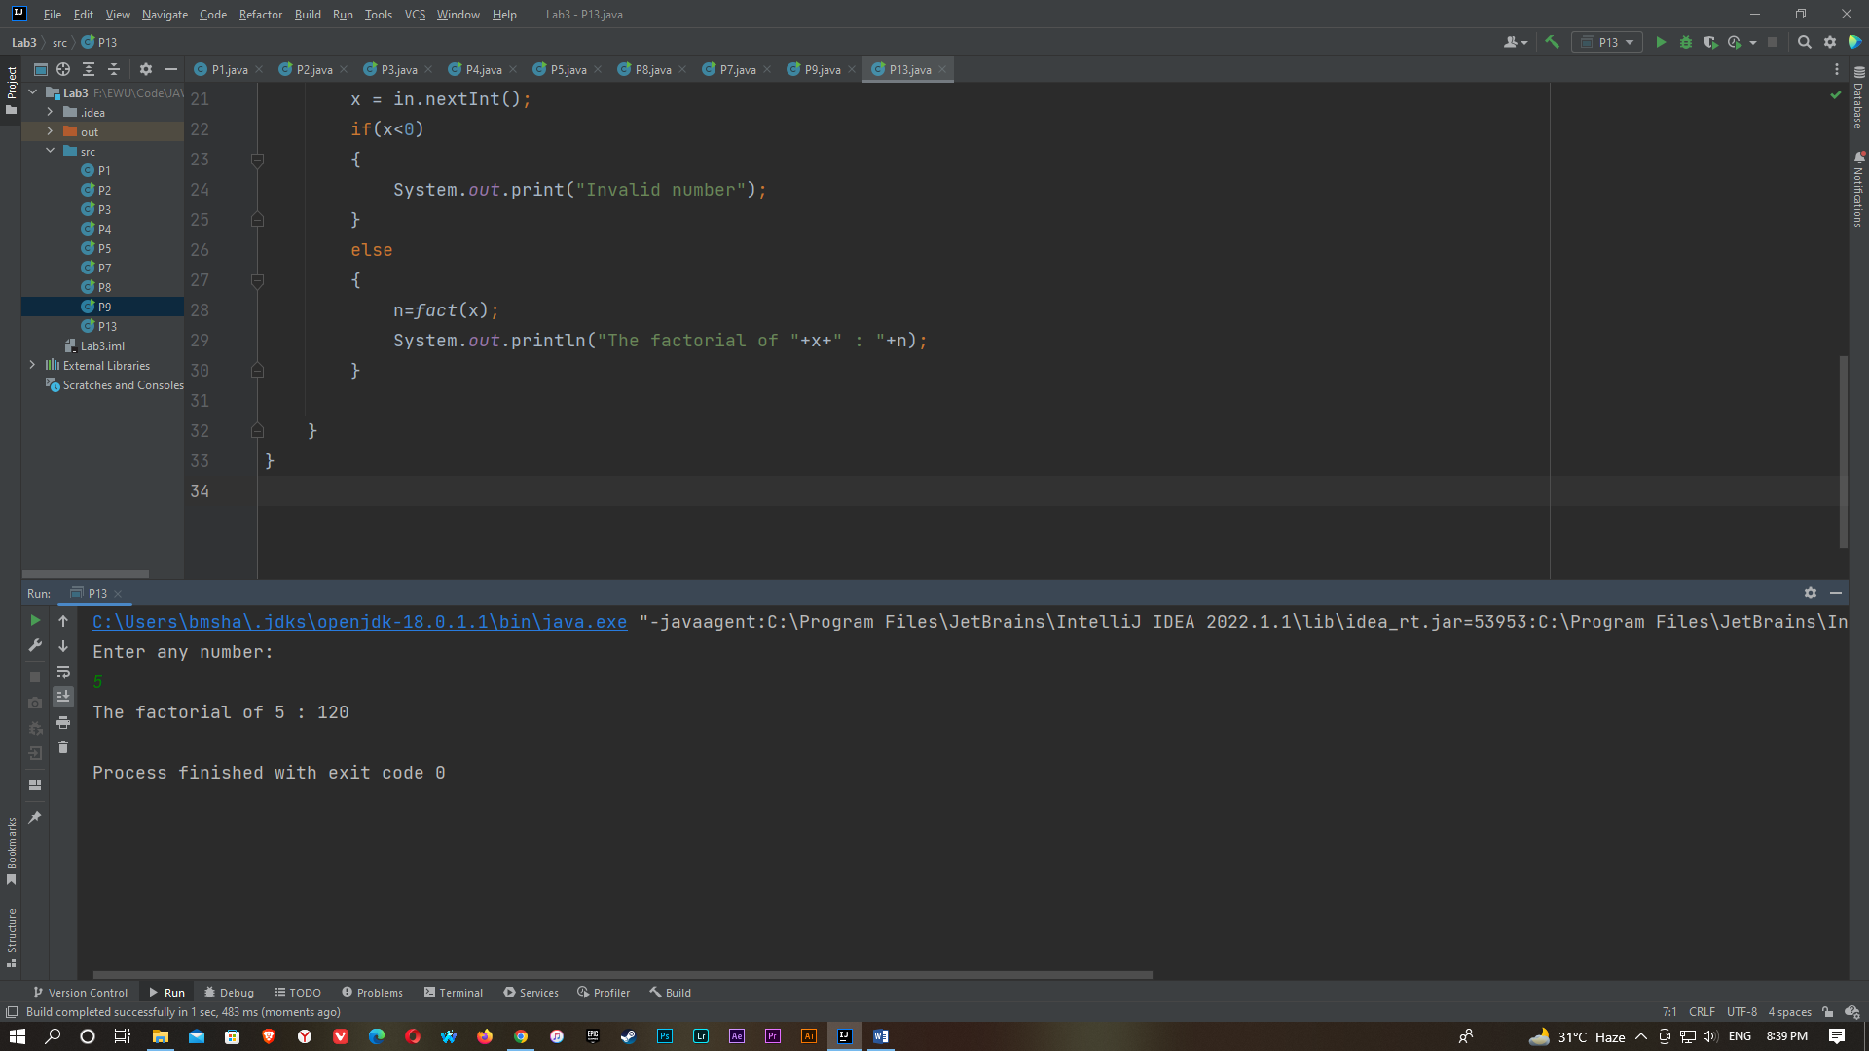

P14)

import java.util.Arrays;

import java.util.Scanner;

public class P14 {

public static void main(String[] args) {

Scanner input= new Scanner(System.in);

System.out.println("Enter the first word:");

String x = input.nextLine();

System.out.println("Enter the Second word:");

String y = input.nextLine();

x = x.toLowerCase();

y = y.toLowerCase();

System.out.println(x);

System.out.println(y);

if(x.length()== y.length())

{

char[]a= x.toCharArray();

char[]b= y.toCharArray();

Arrays.sort(a);

Arrays.sort(b);

boolean z = Arrays.equals(a, b);

if(z)

{

System.out.println(x+" and "+y+" are anagram.");

}

else

{

System.out.println(x+" and "+y+" are not anagram.");

}

}

else

{

System.out.println(x+" and "+y+" are not anagram.");

}

}

}

